Challenge Titel – Smart Watering & Green Energy

Team GBT Watering

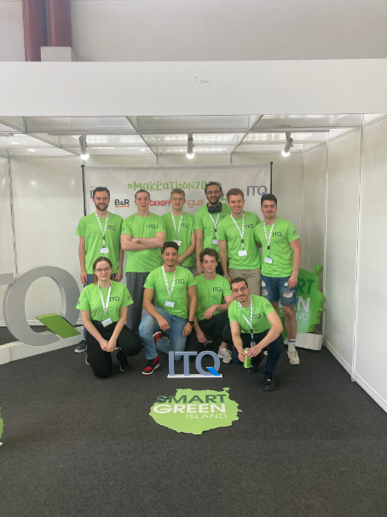 | 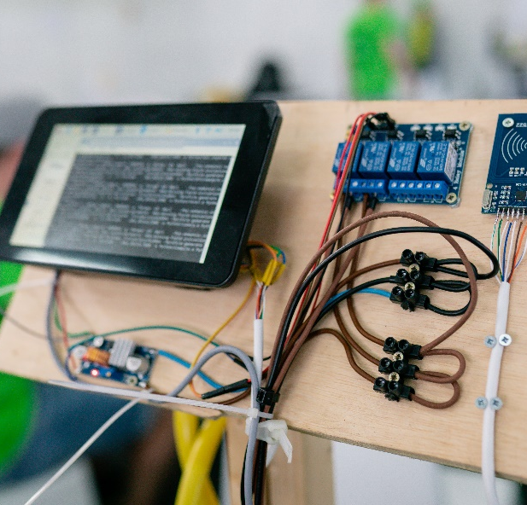
Team: GBT Watering | Prototype

Project Abstract (Minimum 800 Characters incl. Spaces)

The aim of this project is to create an intelligent Smart Watering System that can provide plants with the correct amount of water based on their individual needs. The system will be designed to consider various factors such as the plant species, the local climate, the humidity of the soil and other environmental conditions. The Team GBT Watering developed a system that can accurately identify each individual plant being watered. Once the system has identified the plant, it will be able to calculate the optimal amount of water needed for that specific plant based on its individual requirements. In addition to plant identification and individualized watering, the intelligent Watering System will also be designed to adapt to changing weather conditions. By utilizing humidity sensors, RFID technology, previous dataset, and weather forecast this system will help to promote healthy growth and increase yields.

